

**Global Influences on UK Interest Rates**

Speech given by

Kate Barker, Member of the Monetary Policy Committee, Bank of England

Meeting of the North West Chief Executives’ Club in Wilmslow 25 September 2008

I would like to thank Charlotta Groth and Jake Horwood for research assistance, and others for helpful comments. The views expressed are my own and do not necessarily reflect those of the Bank of England or other members of the Monetary Policy Committee.

1

All speeches are available online at [www.bankofengland.co.uk/publications/Pages/speeches/default.aspx](http://www.bankofengland.co.uk/publications/Pages/speeches/default.aspx)

# *Introduction*

It is a great pleasure to have the opportunity to come and talk to you as the conclusion to my visit to the North-West. The early autumn is often a time when the economic climate changes, as well as the meteorological one. So far both types of weather feel distinctly chilly, and in the financial markets there have been storm-force winds. This visit has been a good moment to find out if and how business sentiment is changing, and over the next two weeks I will also be looking hard at this month’s business surveys.

The economic backdrop is certainly a difficult one. Since the credit turmoil began last August, many of the key indicators of economic health have deteriorated. The GDP growth rate has declined, from 3.3% in the year to the second quarter of 2007 to 1.4% a year later. And in June and July 2008 there was the largest upward change over two consecutive months in CPI inflation since the series began in 1997. The reasons for these large movements are now familiar – the tightening in credit supply sparked off by difficulties in the US sub-prime mortgage sector, and the significant rises in oil and commodity prices which have pushed up inflation and squeezed real incomes. The sterling price of Brent crude oil is over 40% on average higher so far this month, compared with September 2007. A further source of upward inflation pressure is the fall in the sterling effective exchange rate, over 14% weaker so far this month, compared with the average for the first half of 2007. While this last factor should be beneficial here, as manufacturing accounts for over 18% of the North-West region’s value-added, the boost to exports may be limited as growth has also slowed sharply in the EU. And as you will all be aware, the past two weeks have seen an intense period of turmoil in particularly US financial markets, although it is too soon to be clear about the full consequences of these events for the real economy.

In this more stormy economic weather, it is not surprising that some commentators have been questioning whether we are steering by the right compass1. Some criticism

1 For example: ‘The consumer will have to be crucified in order to meet the inflation target as it currently stands….the Chancellor should have a very good look at the specification of monetary policy.’ Peter Spencer (Ernst and Young Item Club) May 18 2008, quoted Daily Telegraph. Also: ‘There are times when central banks should allow consumer price inflation to diverge from its medium-

has been directed at the remit of the Monetary Policy Committee, but, importantly, not at the principle of having an independent body to set Bank Rate. My remarks today will focus on two linked questions which have been raised in this debate, explaining why I consider the remit set for us by the Government remains appropriate:

* Firstly, if import price inflation (including commodity price inflation) remains higher on average over the next decade than in the first decade of the MPC, does a 2% CPI inflation target continue to make sense?
* Secondly, in times of volatile imported inflation, would a switch to targeting some measure of domestically-generated inflation impart less volatility to the real economy?

I will then conclude with some brief comments on the present conjuncture and policy strategy in the light of the considerable economic challenges for the UK, brought into sharp focus by the extreme financial turmoil of recent days.

# *Imported inflation – history and outlook*

For almost the whole of the first ten years of the MPC, UK inflation was surprisingly stable, within 1% either side of the target. Economic growth was continuously positive, and stable compared with the previous 25 years. At the same time there was broad stability of oil and other commodity prices, and a low rate of inflation for imported goods. Consequently, there were large changes in relative prices over this period – with goods inflation on average 3.7 percentage points weaker than services inflation. However, these trends have recently changed. The most recent data shows imported goods prices, excluding oil, up by 9.2% in the year to July, reflecting faster growth of world commodity prices exacerbated by sterling depreciation (Chart 1).

In particular, global food prices have risen sharply, although the rate of increase has slowed to 40% (in US dollars) in August compared to a year earlier (Chart 2). Metals prices, which rose steeply through 2004/05, have however since been more stable (Chart 3). The sharp rise in CPI inflation, from 2.1% last December to 4.7% in August has, in an accounting sense, very largely been driven by these global price

term objective to ensure price stability on a much broader metric.’ Stephen King (HSBC) writing in The Independent, March 31, 2008.

trends, and with some retail gas and electricity prices rises still to feed though, we have probably not yet reached the peak in inflation.

A key uncertainty in the UK short-term outlook is whether imported inflation will continue to mount, slow or even go into reverse if commodity prices start to retreat from their recent peaks. Forecasting the future for these prices is hazardous – not least as the reasons for the extent of the recent increases is not entirely clear. Both for oil and food there seem to have been a combination of demand effects (mainly from rapid growth in China and other Asian economies) and supply effects.

For oil, the supply issues have included a declining margin of OPEC spare capacity, and rising costs of extraction from non-OPEC sources. For food commodities, rising oil prices have increased the costs of food production, and led to the diversion of some crops into biofuels. In 2006/07, these pressures were intensified by poor weather conditions in some of the key producing regions, which have not in general been repeated this year.

In both cases it seems reasonable to suppose that, while the large price increases in 2008 are unlikely to persist year after year, further periods of price volatility are likely for some time due to the fundamentally tighter balance between supply and demand. It is also highly uncertain around what average level of the oil price this volatility will occur. In the short-term, the slowing in global growth which is now expected should ease price pressures, in the absence of unforeseen supply disturbances.

In the longer-term there will be more opportunity for changes in behaviours and in technology that are likely to reduce the oil intensity of GDP. Following the first oil shock, oil intensity fell in OECD countries by almost 10% from 1973 to 1978, and had fallen by one-third by the mid-1980s. Twenty years later it may be harder to achieve such a marked reduction, but already there is evidence of lower automotive fuel usage in the US (and in the UK, where deliveries of motor fuel grew on average by around 0.5% annually in 2000-07, but in the second quarter of 2008 were down almost 1% on a year earlier).

Turning to imported goods inflation excluding the direct impact of energy and food, the conclusion of recent Bank work2 was that the so-called ‘China effect’ on import price inflation (the impact of a rising share of UK imports from low-cost producers) might be coming to an end. So there is some risk that imported goods price inflation will remain a little higher in the next decade than in the previous one.

# *Imported inflation – future impact and the 2% CPI target*

While inevitably there is much uncertainty about any projection – one plausible stylised view of the next few years might be that they will differ from the first decade or so of the MPC in experiencing a higher rate of world goods price inflation and also generally more volatile commodity prices. Neither of these is inevitable, and indeed the former effect may well be mitigated if alternative low-cost producers emerge, or if there is further switching of sourcing towards low-cost producers. These two factors would have different implications for monetary policy.

Were there to be a higher rate of world goods price inflation, this does not necessarily mean there is an impact on UK CPI3. The impact on the UK of higher Chinese inflation, for example, could certainly be offset by UK monetary policy. This is likely to be a combination of changes in UK interest rates and in the exchange rate – as the anticipated higher nominal interest rate to keep inflation at target would tend to result in exchange rate appreciation. In practice, of course exchange rates sometimes deviate for long periods from their estimated equilibrium, putting more of the adjustment through interest rates. The linkage between Chinese and other Asian currencies to the US dollar may have impeded exchange rate adjustment in the early 2000s.

It is obviously true that if the inflation rate of imported goods increases, then relative inflation rates will need to change. But the scale of this effect should not be exaggerated. Looking at the CPI, over the first decade of the MPC (to mid-2007), goods price inflation averaged around zero, and services inflation averaged 3.7% (see

2 Mac Coille (2008)

3 Bowen and Mayhew (2008) discuss these issues in more detail

Chart 4). The previous Bank work4 estimated that the ‘China effect’ reduced UK manufactured goods import price inflation by around 0.7 percentage points on average in 2000-06. (There is inevitable uncertainty here, but this can be taken as a broad indication.) The impact on overall goods prices would clearly have been rather less.

So if this effect comes to an end, it would probably imply only a modest necessary reduction in the rate of service prices inflation, to keep inflation at the target.

Recently, services inflation has tended to rise, but this will at least in part reflect the impact of higher energy prices feeding through. The rise in energy prices is leading to a rather more prolonged hump in overall inflation than the MPC expected earlier this year, but as this effect fades inflation, including in services, is expected to decline.

Of course, this does not mean that either the recent large increase in the level of commodity prices, some of which may well be sustained, or the higher import price inflation, will have no real effects on the UK economy. Both of these will tend to reduce real wages as import prices rise relative to the prices of goods produced in the UK. Relative to a situation in which these changes had not occurred, the level of economic activity in the UK will be lower, although once this adjustment has occurred the future growth rate of output consistent with stable inflation is unchanged. But this effect could not be avoided by having a higher inflation target, as this would result either in an offsetting exchange rate depreciation, or in an erosion of competitiveness in export markets.

In any case, it is important to remember that when the move to inflation targeting was implemented, there was no particular Government expectation that a low rate of inflation was appropriate because the UK was about to benefit from the ‘China effect’. Rather, it reflected the general view that a low, positive rate of inflation is broadly optimal.

4 Mac Coille (2008)

# *Is consumer price inflation the right target measure?*

If the UK has moved from a period of several years in which both the exchange rate and commodity prices were broadly stable, into one in which there may be further CPI volatility due to price shocks emanating from outside the UK, this raises questions about how monetary policymakers should respond to these kind of shocks.

The most obvious of these is the familiar issue about to what extent policymakers should ignore the initial effects of, for example, oil price rises on the economy. Here there is broad agreement that policymakers should generally not seek to offset the impact, upward or downward, on inflation unless there are signs that the change in inflation is likely to become embedded in wage increases and thus move inflation more persistently higher, or lower. These policy judgements become more difficult if the shock is very large, or if, as at present, there is a sequence of shocks so that these ‘first round’ effects alone push inflation away from target for an extended period. In these circumstances there is more risk that inflation expectations will move away from the inflation target. At present I remain somewhat concerned about the possibility of more persistent higher inflation, even as growth slows.

A more fundamental challenge to policy is posed by the argument that policymakers should not be targeting consumer price inflation, but rather focusing on some measure of domestic output price inflation. A number of studies5 have proposed alternative rules for setting interest rates along these lines.

A general argument made in favour of this proposition is that it would avoid the economic and social costs which can arise from fluctuations in the domestic economy. It is suggested that this is undesirable to allow temporary changes in the ratio of export and import prices, away from some long-run equilibrium, to push consumption away from its long-run sustainable path. The relevance to the present circumstances is clear – it would imply that part of the increase in UK household consumption in recent years was enabled by an unsustainably weak trend of import prices, and now as

5 For example: Kirsanova, Leith and Wren-Lewis (2006); Gali and Monacelli (2005)

this reverses, an undesirable price is being paid in terms of a period of weak consumption growth.

There are however a number of arguments against the approach. One benefit of targeting CPI inflation is that it is reasonably well-measured, and is not revised. Consumer price inflation is also a widely recognised concept, and individuals understand how it broadly relates to their own circumstances. Measures of domestically-generated inflation are often uncertain (for example, the Bank has published a range of estimates of domestically-generated inflation,6 which suggests that this can only be measured within a band, due to uncertainty about the degree of pass-through from import prices to CPI). An alternative might be to use the GDP deflator excluding export prices, but the early estimates of the GDP deflator are subject to considerable revision.7 Whatever approach is taken to monetary policy, it is inevitable that some of the key concepts used to guide decisions will be difficult to measure – the degree of spare capacity in the economy at any point in time is very uncertain, and the past history of the estimates is often revised. But it could prove rather difficult to establish credibility in a regime which targeted an uncertain and unfamiliar inflation measure.

Rather more importantly, this change in approach might well not achieve its goal of a greater degree of overall economic stability. It cannot be assumed that the rate of inflation will respond mechanically to a given condition of the real economy – put another way, that a 1% margin of spare capacity will always reduce inflation to the same extent. Much is also likely to turn on the role of inflation expectations. As far as wage-setting is concerned it will be some measure of consumer price inflation, current and expected, which plays a role (although not always the leading role) in wage negotiations.

Proponents of using only domestic inflation as the target tend to argue that, as an upward external shock to inflation eventually fades, expectations based on CPI will come back down to be consistent with a low rate of inflation, even if CPI has been above domestic inflation for some time. But this means that, for modest short-lived

6 Bank of England *Inflation Report* August 2006, page 35-36

7 Cunnningham and Jeffery (2007)

external shocks, targeting domestic inflation would in effect be no different from targeting CPI, and allowing first-round effects to feed through. The challenge for both a CPI and a domestic inflation targeting regime comes when the external price shock is prolonged, as the ’China effect’ was, or very large and prolonged, as the present oil/food price shock is proving to be.

My main objection is that targeting some measure of domestic inflation could mean having periods of CPI inflation persistently well below, or well above, the present target. Under this regime, during much of the 2000s, CPI probably would have been kept well below the present 2% target, with dangers of inflation expectations becoming de-anchored downward and creating a problematic deflation. Today the opposite worry, upward de-anchoring of expectations, would be created. A CPI target provides a clear guide to acting to keep inflation expectations anchored as far as possible, and avoiding the risk of the nominal (money and inflation) side of the economy becoming dislodged with regard to the real side (essentially, movements in spare capacity). I am not convinced that this would be achieved by targeting only domestic inflation.

# *Current policy problems*

I do not think that the present more difficult economic circumstances provide any reason for changing the inflation target, and indeed to do so now would be to run considerable risks with credibility. But the policy challenges today are more complex than any others in my time on the MPC since June 2001, so that it is vital to consider how to use the flexibility provided for in that framework. This is not just because CPI inflation has moved so far from the target, but also due to the size of the shocks presently impacting on the UK economy, and considerable uncertainty about their effects.

Looking first at the credit squeeze; this has proved to be a very much more serious, and durable, shock than was initially expected when it began last summer. Given the recent exceptional events in financial markets, there is more uncertainty about what the final scale of the shock to the economy from this source will be, and it is this which matters for monetary policy. For the financial sector itself the adjustment is

proving highly painful and it is clear that lending by UK banks will be very constrained, relative to the past few years, for a considerable period.

The MPC will clearly be looking hard at the impact of these recent events in our October meeting and as we update our forecasts in November. In the mortgage market, even prior to September, while prime borrowers with low loan-to-value ratios had been little affected, for many first-time borrowers with access to only small deposits credit had been very limited. Anecdotal evidence from the Bank’s Agents had also suggested that corporate credit was becoming more difficult to obtain in certain sectors, and also in some cases more expensive, consistent with messages from the Bank’s Credit Conditions survey for the second quarter of 2008. These problems may now be intensified.

The downward pressure from tighter credit on household consumption has also been exacerbated by the squeeze on real incomes consequent on the rising costs of food and energy. Signs of economic weakness, at first very much focused in the financial and construction sectors, have started to spread out. In particular, car sales have declined more than usual ahead of September (when a boost from the new number plate would normally be expected) and retail sales, though volatile month-to-month, seem to be slowing on a quarterly basis. Although some business surveys picked up a little in August, the overall picture remains that business conditions have weakened very significantly during 2008, and the CBI manufacturing survey deteriorated in September.

Upward pressure on inflation may have eased somewhat since the beginning of August due to the fall in oil prices, reflected in the decline in the August data for producer price inflation. However, the lower dollar oil price had been offset to some extent by the recent decline in sterling (now partially reversed). Lower sterling brings positive news for output, as, if sustained, it will support a stronger contribution to UK growth from net trade over the MPC’s forecast period. However, it also brings a cost in terms to higher import prices, keeping inflation higher.

News on labour costs continues to suggest that higher inflation is not feeding into higher wages - private sector pay growth, excluding bonuses, has changed little over

recent months. But inflation expectations as well as perceptions have clearly moved higher during 2008. For example the expectation of the median respondent in the latest Bank of England/NoP survey is for inflation of 4.4% over the next 12 months, up 1.7 percentage points from a year earlier. So it may be too soon to dismiss completely the risk of significantly higher wage growth in the wage round early in 2009, although it is now receding as the labour market weakens.

Concern over the risk that higher inflation could become embedded is justified. Were monetary policy to be insufficiently restrictive, and allow this risk to become reality, this would produce one of the worst possible outcomes. A more broadly-based inflation would mean that the MPC would need to generate a considerable amount of spare capacity to bring inflation back to target, with obvious major costs, including rising unemployment and further strain for already stressed financial institutions. But the latest developments in financial markets have now increased the downside risks. There are real dangers that the impact of these will be a downturn in the economy which is unnecessarily large, and would therefore result in a large undershoot of the inflation target.

In these circumstances, judgements about the timing of any change in policy that may become necessary are particularly difficult. In addition, continually changing credit conditions means that it is not easy to form a clear view about the restrictiveness of a 5% Bank Rate. The risks to the economy, and to credibility, from mistakes in either direction are unusually large.

# *Conclusion*

In these remarks, I have set out why I believe it likely that global inflation may run a little higher, and be more volatile, over the next few years. If these changes occur, there are certainly implications for monetary policy. Higher global inflation would tend to require a period of tighter policy; whereas more volatile commodity prices will require policy with a keen eye on inflation expectations to keep inflation anchored at target in the medium term.

I have also explained that I am not persuaded by arguments suggesting that the changes in the global inflation outlook mean either that the inflation target should be raised, or that the price index being targeted should be changed in a fundamental way. A move to targeting domestically-generated inflation has some attractions, but these are in my view outweighed by the practical and communication issues. In addition, in the event of a prolonged sequence of global inflation shocks such as we have recently experienced, this change would not resolve the all-important uncertainties around inflation expectations.

It is an illusion to think that changing the framework would alter the set of problems which we confront today – a higher level of raw material prices, implying a needed reduction in real income growth for employees, arriving at the same time as a severe credit squeeze resulting from the need for major restructuring in the financial sector. Monetary policy cannot insulate the real economy from real shocks, or indeed from dislocation in financial markets, only mitigate their worst effects by managing inflation over the medium-term.

I have also described the different risks which we face, and sketched ways in which these interrelate. This complexity means that the future path of Bank Rate remains highly uncertain as the significant risks to the inflation target in both directions are reassessed month by month. In the immediate future I will be looking hard at survey data to get an early reading of how far the business and consumer mood and behaviour is being affected by serious financial market turmoil.

There are also questions to consider about tactics. The large and sustained rise in commodity prices, accompanied by a significant deterioration in the exchange rate, implies a lengthy period of above target inflation, even though CPI inflation is likely to fall back markedly over the next few quarters. To bring CPI inflation back to 2% in two years, unless there is an unexpected shift in some of these external factors, might prove demanding. On the other hand, if commodity prices do fall unexpectedly far, this could take inflation well below target for a time. This is a different environment from my early years on the MPC, when we agonised over small deviations from the inflation target around the two-year forecast horizon. But in either case the task of the MPC would be to communicate that policy is being set in a forward-looking manner with a determination to achieve the 2% CPI target over the

medium term. I am convinced that this clarity will provide the right background for those setting wages and prices over the coming months.

**References**

**Bowen, A and Mayhew, K (2008)** ‘Globalisation, import prices and inflation: how reliable are the ‘tailwinds’?’ *Bank of England Quarterly Bulletin,* Vol 48, No 3.

**Cunningham, A and Jeffery, C (2007)** ‘Extracting a better signal from uncertain data’ *Bank of England Quarterly Bulletin,* Vol 47, No 3.

**Kirsanova, T, Leith, C and Wren-Lewis, S (2006) ‘**Should Central Banks Target Consumer Prices or the Exchange Rate?’ *Economic Journal* Volume 116, No 512.

**Gali, J and Monacelli, T (2005)** ‘Monetary policy and exchange rate volatility in a small open economy’, *Review of Economic Studies*, Vol. 72, pp 707-34.

**Mac Coille, C (2008)** ‘The impact of low-cost economies on UK import prices’

*Bank of England Quarterly Bulletin* Volume 48, No 1.

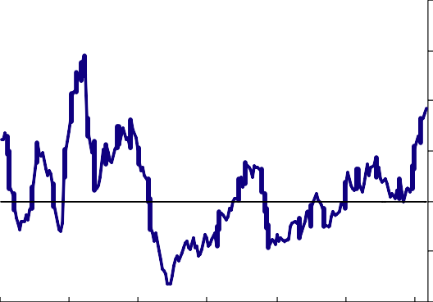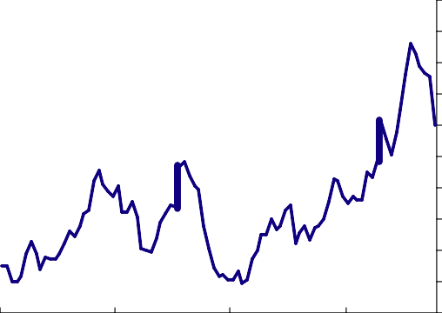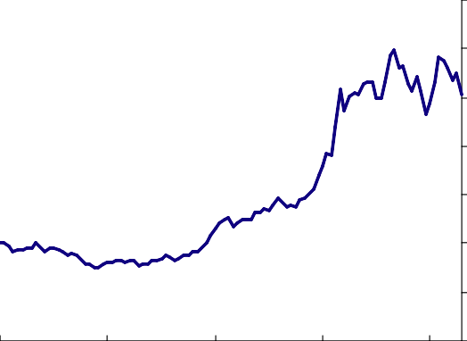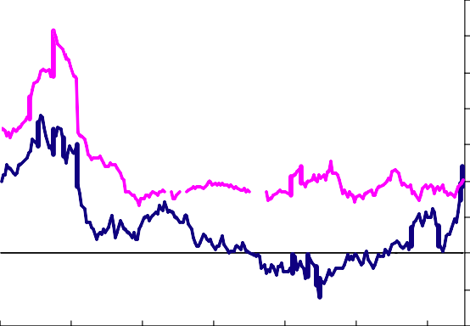

|  |  |  |  |
| --- | --- | --- | --- |
| **Chart 1:** Sterling goods import prices | | | **Chart 2:** Food price inflation |
| Percentage change on a year earlier  20  Goods import price (excl. oil)  15  10  5  0  -5  -10  1990 1993 1996 1999 2002 2005 2008 | | | Percentage change on a year earlier  80  70  60  The Economist food index(a) 50  40  30  20  10  0  -10  -20  2001 2003 2005 2007 |
| Source: ONS | | | Sources: The Economist and Thomson Datastream  (a) Monthly averages of weekly US dollar data. |
| **Chart 3:** Metal price index(a) | | | **Chart 4:** Goods and services inflation |
|  |  | Index, Jan 2000 = 100 | Percentage change on a year earlier  14  CPI services 12  10  8  6  4  CPI goods 2  0  -2  -4  1989 1992 1995 1998 2001 2004 2007 |
|  |  | 350 |
|  |  | 300 |
|  |  | 250 |
|  | The Economist metals index | 200 |
|  |  | 150 |
|  |  | 100 |
|  |  | 50 |
|  |  | 0 |
| 2000 | 2002 2004 | 2006 2008 |
| Sources: The Economist and Thomson Datastream  (a) Monthly averages of weekly US dollar data. | | | Source: ONS |